Spurious correlation

I chose for the following graph:

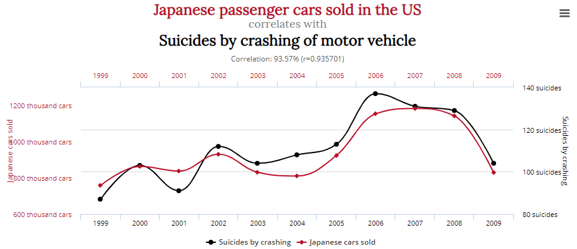

Most of the graphs didn’t really make sense to me, but I could make some sense out of this one. There is a direct relation between the sales of a car and the suicides by crashing. If you look at the flow of the graph, you could see that overall, there is a trend that if there are less cars sold, there are less suicides, and vice-versa.

It goes for show the there are less suicides by crashing your motor vehicle because there are less cars being sold, thus less cars being on the actual road.

Less sales means less targets to crash into.